11. Home Finder, an innovative online real estate platform, simplifies the property search and transaction process for buyers, sellers and renters. The website has a database of residential and commercial properties with search filters for location, price, type and amenities. Key functionalities include user registration and login, detailed property listings, interactive maps to explore neighbourhoods, scheduling property viewings, saving favourite listings and search criteria, agent and company search, mortgage and valuation tools, and direct communication with agents. Buyers log in and save their search criteria so the same criteria can be reused. The website also shows advertisements and links to other websites, displays property locations on Google Maps, stores property details, and maintains a record of customers who visited the website.
AIM
To design a simple Property Search webpage where a buyer can log in, search houses, land and apartments by location, type and budget, save and reuse the search criteria, view the property on Google Maps, schedule a viewing, and search for an agent or company.
HTML CODE
<!DOCTYPE html>
<html lang="en">
<head>
<meta charset="UTF-8">
<meta name="viewport" content="width=device-width, initial-scale=1">
<title>Home Finder - Property Search</title>
<style>
body { font: 16px Arial, sans-serif; max-width: 650px; margin: 40px auto; padding: 20px; color: #222; background: #f1f8f4; }
h1 { color: #1b7f4b; }
section { border: 1px solid #c5e3d2; background: #fff; border-radius: 8px; padding: 20px; margin: 20px 0; }
input, select, button { padding: 10px; margin: 6px 0; width: 100%; box-sizing: border-box; }
button { background: #1b7f4b; color: #fff; border: 0; border-radius: 6px; cursor: pointer; }
.ad { background: #fff3cd; border: 1px dashed #d9a400; padding: 10px; text-align: center; border-radius: 6px; }
.prop { border-bottom: 1px solid #eee; padding: 8px 0; }
.ok { color: #146c43; font-weight: bold; }
</style>
</head>
<body>
<h1>Home Finder</h1>
<div class="ad">Advertisement: Home loans from 8.5% - <a href="https://www.example.com" target="_blank">Apply now</a></div>

<section>
<h2>Buyer Login</h2>
<input id="user" placeholder="Username">
<input id="pass" type="password" placeholder="Password">
<button onclick="login()">Login</button>
<p id="loginMsg"></p>
</section>

<section>
<h2>Search Property</h2>
<select id="loc"><option>Chennai</option><option>Coimbatore</option><option>Madurai</option></select>
<select >
</section>
<section>
<h2>Find Agent</h2>
<input id="agent" placeholder="Agent or company name" oninput="findAgent()">
<p id="agentResult"></p>
</section>

<p id="visits"></p>

<script>
const props = [
{name: "3BHK House, Adyar", loc: "Chennai", type: "House", price: 85},
{name: "Residential Plot, Porur", loc: "Chennai", type: "Land", price: 45},
{name: "2BHK Apartment, Velachery", loc: "Chennai", type: "Apartment", price: 60},
{name: "Villa, Saibaba Colony", loc: "Coimbatore", type: "House", price: 95}
];
const agents = ["Ravi Estates", "Sri Homes Realty", "Prime Properties"];
let saved = null, loggedIn = false, visitors = 128;
function login() {
}
function search()
function saveCriteria() {
saved = {loc: loc.value, type: type.value, budget: budget.value};
saveMsg.className = "ok";
saveMsg.textContent = `Criteria saved: ${saved.type} in ${saved.loc} up to Rs.${saved.budget} lakhs.`;
}
function useSaved() {
if (!saved) { saveMsg.textContent = "No saved criteria."; return; }
loc.value = saved.loc; type.value = saved.type; budget.value = saved.budget; search();
}
function book(name) {
saveMsg.className = "ok";
saveMsg.textContent = "Viewing scheduled for " + name + " on Saturday, 11:00 AM.";
}
function findAgent() {
const q = document.getElementById("agent").value.toLowerCase();
agentResult.textContent = q ? agents.filter(a => a.toLowerCase().includes(q)).join(", ") || "No agent found." : "";
}
visits.textContent = "Total visitors so far: " + (++visitors);
</script>
</body>
</html>

OUTPUT
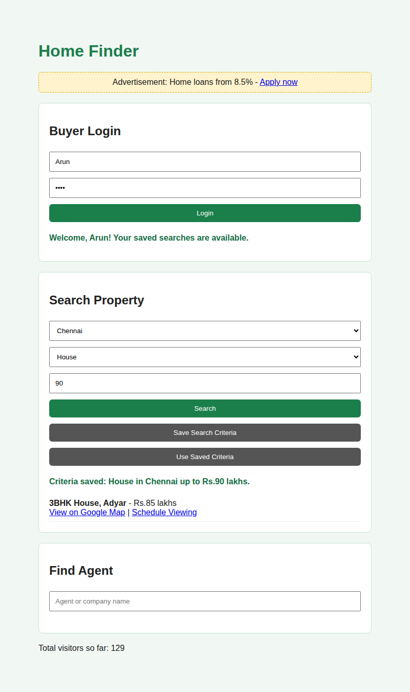  Output 1: Login, property search and saved criteria | 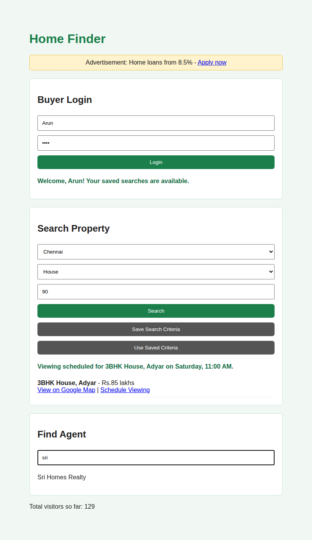  Output 2: Saved criteria reused, viewing scheduled, agent search
RESULT
The Home Finder webpage was created successfully. It logs in the buyer, filters properties by location, type and budget, saves and reuses the search criteria, links each property to Google Maps, schedules a viewing, searches agents, shows an advertisement and counts the website visitors.

